

**CS6004NI: Application Development**

**30% Group Coursework**

**2025 spring**

|  |  |  |  |
| --- | --- | --- | --- |
| **Group Name:** | | | |
| **SN** | **Student Name** | **College ID** | **University ID** |
| **1** | **Miraj Deep Bhandari** | **np01cp4a220197** | **22067814** |
|  | Enter your Full Name Here | E.g. NP01MM0474747 | E.g. 18053646 |
|  | Enter your Full Name Here | E.g. NP01MM0474747 | E.g. 18053646 |
|  | Enter your Full Name Here | E.g. NP01MM0474747 | E.g. 18053646 |
|  | Enter your Full Name Here | E.g. NP01MM0474747 | E.g. 18053646 |
|  | Enter your Full Name Here | E.g. NP01MM0474747 | E.g. 18053646 |

**Assignment Due Date: Thursday, April 17, 2025**

**Assignment Submission Date: 2025-05-**

**Word Count:**

**Project File Links:**

|  |  |
| --- | --- |
| **Drive Link:** | Keep Drive URL of your Project Here with Anyone in Organization can View Option Enabled |

*I confirm that I understand my coursework needs to be submitted online via My Second Teacher under the relevant module page before the deadline in order for my assignment to be accepted and marked. I am fully aware that late submissions will be treated as non-submission and a marks of zero will be awarded.*

**Table of Contents**

1. INTRODUCTION: 4

1.1 PURPOSE: 5

1.2 SCOPE: 5

1.3 OBJECTIVES: 6

2. FEATURES & FUNCTIONALITIES: 7

2.1 KEY FEATURES: 7

2.1.1 Advanced Catalog System: 7

2.1.2 Membership Management: 7

2.1.3 Shopping Cart and Order Processing: 7

2.1.4 Loyalty and Discount Program: 7

2.1.5 Review and Rating System: 8

2.1.6 Admin Control Panel: 8

2.1.7 Notification System: 8

2.2 CORRESPONDING FUNCTIONALITIES: 9

2.3 VISUAL GUIDES: 13

3. PROOF OF WORK: 14

3.1) USE CASE DIAGRAM: 14

3.2) SEQUENCE DIAGRAM: 15

3.3) VCS REPOSITORY: 18

3.4) MILESTONE CHART: 19

3.5) ERD DIAGRAM: 20

3.6) TESTINGS: 21

3.7 ) Tools & Technologies Used: 22

4. INDIVIDUAL REFLECTION: 24

4.1 ROLES & RESPONSIBILITIES: 24

5. CONCLUSION: 27

5.1 OBJECTIVE RESTATEMENT: 27

5.2 IMPLICATIONS: 27

5.3 KEY FINDINGS: 27

5.4 LIMITATIONS: 28

5.5 RECOMMENDATIONS: 28

5.6 FUTURE RESEARCH & DEVELOPMENT: 28

5.7 CONCLUDING STATEMENT: 29

6. REFERENCES: 30

**Table of Figures**

Figure 1: Use Diagram Diagram 14

Figure 2: Sequence Diagram for Member 15

Figure 3: Sequence Diagram for Staff 16

Figure 4: Sequence Diagram for Admin 17

Figure 5: Milestone Chart Diagram 19

Figure 6: Entity Relationship Diagram 20

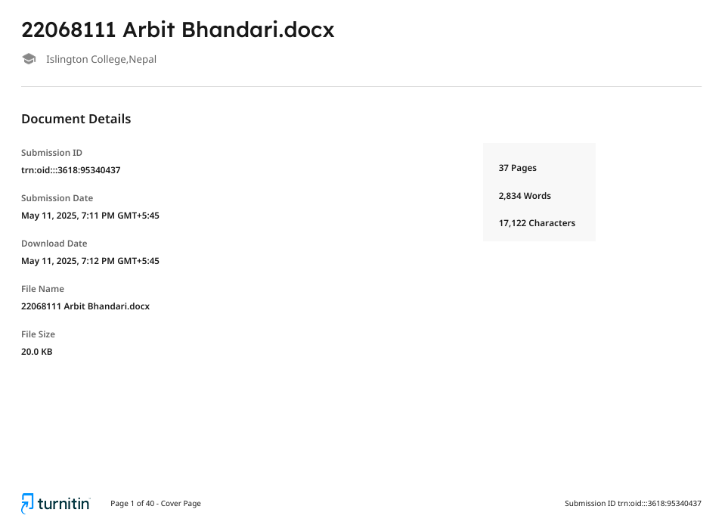

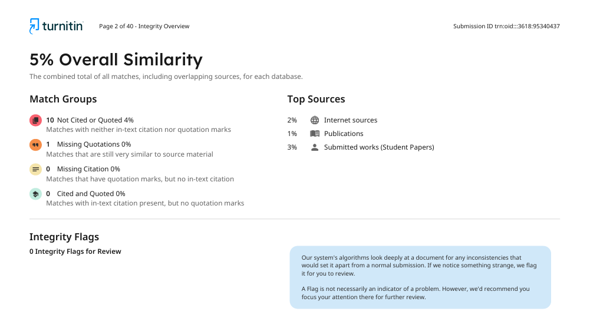

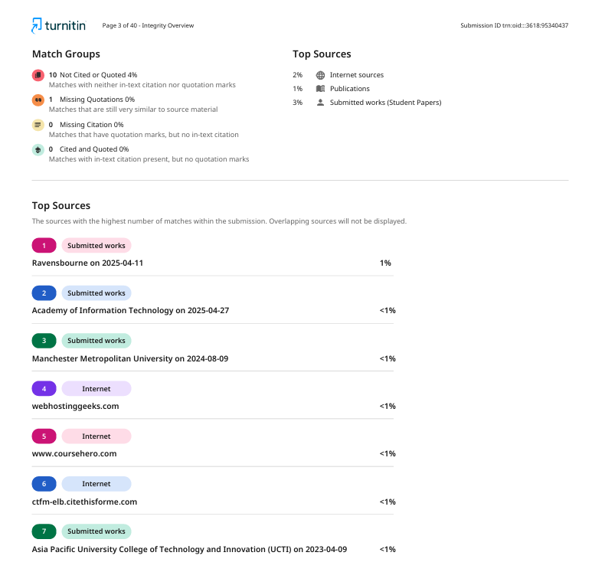

# 1. INTRODUCTION:

This project describes the creation of an extensive online book retail system for a private library shop interested in opening its business domain outside its physical location. Built on C#.NET technology, the system allows for conversion of conventional physical shop operations into an active e-commerce system. The system overcomes essential business issues of limited access to customers, limited operational time frames, and no visibility of remote stock while maintaining individualized service that defines the identity of the shop. With the introduction of its digital solution, the library shop places itself competitively in today's marketplace while providing new avenues for expansion and clientele interaction.

The application we developed includes a full-featured catalog management system that enables customers to search and browse books based on multiple filtering criteria like author, genre, availability, price range, ratings, language, and format. The application organizes books into easy to understand categories including bestsellers, award winners, new releases, new arrivals, future releases, and special prices to promote discovery and navigation. The application features a membership aspect that allows users to create accounts, select favorites, manage carts, and checkout for in-store pickup. The order history gives regular customers discount through the loyalty program that tracks order size and frequency.The use of the store by regular customers encourages repeat business. The application allows members to post reviews and ratings after making a purchase. The community-driven review system contributes to the book catalog as a resource for members, as well as information that can be provided to store management about customer preferences, and satisfaction.

The system offers a complete operational solution while simplifying the core business processes of order management, stock management and promotional coordination. Administrators have full control of the digital catalog as it provides a graphical user interface (GUI) to create, edit or delete book entries. Discounts can be applied to regularly stocked items through price specials or limited time promotional announcements. A notification system is used to send real-time messages about new arrivals, upcoming events or store news. The application architecture has been developed to promote a sustainable approach in designing a system that is secure, fast, scalable and rich in user experience. The claim code system supports an omnichannel experience by allowing the book dropped off for in-store pickup without smartphone payment. In conclusion, while consumers enjoy the convenience of buying a book online, they still benefit from a more personalized shopping experience in the store.

## PURPOSE:

The overall purpose of the project was to build a digital extension to an existing library store in a physical form so that customers could view and purchase books virtually. The goal was to provided an e-commerce experience to peers to avoid limiting customer interaction by way of geography and time as the store is available online 24/7. The app serves an important role in providing a service that affords customers the convenience of shopping online with the service of shopping in store; while still operating like a personable modern individual library business, which adds the personal component that would distinguish it from competition. The system also affords an opportunity for an increased level of customer engagement through personalization and improved efficiencies for the organization through more streamlined administrative processes.

## 1.2 SCOPE:

The project involves the design and implementation of an online book retailing application with both a customer-facing experience and an administrative experience. The customer-facing application comprises catalog browsing - with a complete feature set and powerful filtering account management, online ordering for in-store pickup, a loyalty program, and reviews. The administrative experience includes catalog management, inventory management, management of discounts and promotions, and the ability to make announcements. The project does not include online payment processing or shipping. The business model assumes in-store pickup for completing the transaction. Future growth can expand that down the line.

## 1.3 OBJECTIVES:

The key objectives of this project include:

* To design an easy to use interface where customers can browse, search for, and filter books based on multiple conditions.
* To create a secure memberships system with bookmark capabilities, cart management, and order progress tracking.
* To create, with email confirmations and claim codes, an automated order processing workflow.
* To create a merits based loyalty program with discount options for frequent customers.
* To develop a robust and feature-rich catalog and inventory management system that includes a place for an admin panel.
* To develop a flexible and dynamic discounting system, that could be used for marketing campaigns.
* To implement security into its design and application using the best practices.
* To implement a system-level plan that can easily be integrated with current in store systems.

# 2. FEATURES & FUNCTIONALITIES:

## 2.1 KEY FEATURES:

### 2.1.1 Advanced Catalog System:

* All-inclusive book catalog with comprehensive information.
* Ability to set detailed filtering and search criteria.
* Ability to browse by category with dedicated browsing sections.

### 2.1.2 Membership Management:

* Ability for users to register and authenticate themselves.
* Users will have personalized profiles.
* Users will have bookmarking (wish list) functionality.
* Users will have the ability to track orders in their history.

### 2.1.3 Shopping Cart and Order Processing:

* Cart management.
* Order submission for in-store pickup.
* Order cancellation functionality.
* Confirmation email with claim code generation.

### 2.1.4 Loyalty and Discount Program:

* Discounts based on volume (5 % on 5 or more books).
* Rewards based on frequency (10 % after 10 successful orders).
* Stackable discounting.
* Extra incentives provided by sales and specials.

### 2.1.5 Review and Rating System:

* Capabilities to review after purchase
* Star rating systems
* Comments system

### 2.1.6 Admin Control Panel:

* Ability to manage the catalog entirely (CRUD functionality).
* Ability to manage inventory.
* Ability to manage discounts.
* Ability to create and publish announcements.

### 2.1.7 Notification System:

* Ability to publish time sensitive announcements.
* Ability to publish new arrivals notifications.
* Ability to establish alerts for deals and promotions.

## 2.2 CORRESPONDING FUNCTIONALITIES:

**Advanced Catalog System:**

**1) Book Filtering:** Users can filter books by author, genre, availability, price range, ratings, language, format, and publisher.

**2)** **Book Searching:** The search functionality can be used to search for books by title, ISBN, or description.

**3) Availability of Sorting Options:** Books can be sorted by title, publication date, price, or popularity.

**4) Browsing by Category:** There are tabs for different browsing categories, including: All Books, Bestsellers, Award Winners, New Releases, New Arrivals, Coming Soon, and Deals.

**5) Book Details:** Each book entry will have a detail page with descriptions of comprehensive information for each entry including potential format options of each entry being paperback, hardcover and exclusive editions.

**Membership Management:**

1. **User registration:** New users can register and create an account using their personal information and log in credentials.
2. **Authentication:** A secure login system for all members.
3. **Profile Management:** Members are able to view and update their profile information.
4. **Account Dashboard:** A consolidated view of your order history, your saved books, and your available discounts.
5. **Bookmark:** Members can bookmark books to their wishlist for future reference.

**Shopping Cart and Order Processing:**

**1) Cart Management:** Add, delete, and modify the quantity of books in the shopping cart.  
  
**2) Order Placement:** Complete selecting and place orders for store pickup.  
  
**3) Order Cancellation:** Ability to cancel orders pending pickup.  
  
**4) Pickup process:** System generates unique claim codes for in-store verification.  
  
**5) Confirmation System:** Automatic emails created with details of order, claim code, and receipt.

**Loyalty and Discount Program:**

1. **Wholesale Bulk Discount:** Automatically applies a 5% discount for orders with 5 or more books.
2. **Loyalty Rewards Program:** After 10 successful orders, you will receive a 10% discount.
3. **Discount Stacking:** You will be able to combine charges you've incurred by an earned discount you receive.
4. **Promotional Discounts:** Time limited promotions on select titles.
5. **Discount Planning:** Our system will automatically track the discounts you qualify for as a member.

**Review and Rating System:**

1. **Post Purchase Reviews:** Reviews can only be left by members after purchasing a book.
2. **Rating Systems:** A star rating to quickly establish member assessment or position.
3. **Written Reviews:** Comments and reviews can also be added for detailed comments.
4. **Review management:** All reviews are associated for a verified purchase for validity.
5. **Overall ratings:** Overall ratings reflected as total scores or reviews based on all member reviews.

**Administrative Control Panel:**

1. **Book Management:** Platform for the creation, modification, and removal of books.
2. **Discount Management**: Deciding to apply discounts to a single books or a category
3. **Order Processing:** Admin interface to view and approve customers orders.
4. **Inventory Control:** Resources for controlling stock and availability.
5. **Promotion Dates:** An interface option for start and end date of promotional periods.

**6) Discount Management**: Deciding to apply discounts to a single books or a category.

**Notification System:**

1. **Customer Message Interface:** An option that can be taken to setup and publish store announcements.
2. **Timed messages:** Option to publish an announcement for a set amount of time.
3. **New Books**: Automatic notifications of new book arrivals.
4. **System Messages:** Notifications of important changes or updates in the system.
5. **Deal Messages:** Announcements of promotional announcements for deals and discounts.

## 2.3 VISUAL GUIDES:

# 3. PROOF OF WORK:

## 3.1) USE CASE DIAGRAM:

Figure 1: Use Diagram Diagram

## 3.2) SEQUENCE DIAGRAM:

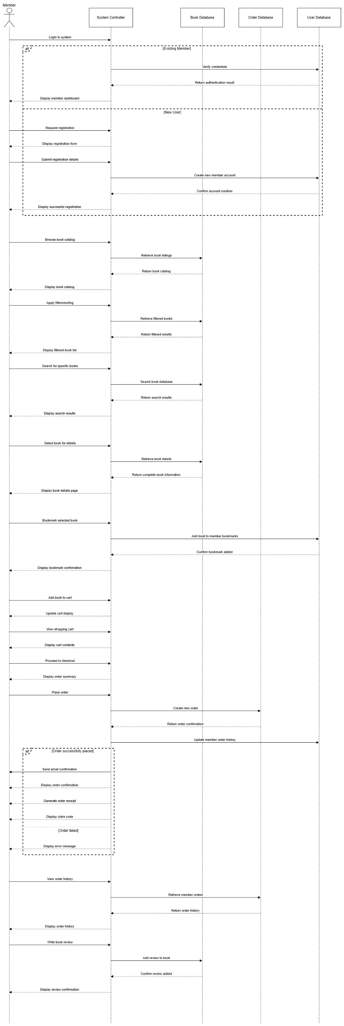

Figure 2: Sequence Diagram for Member

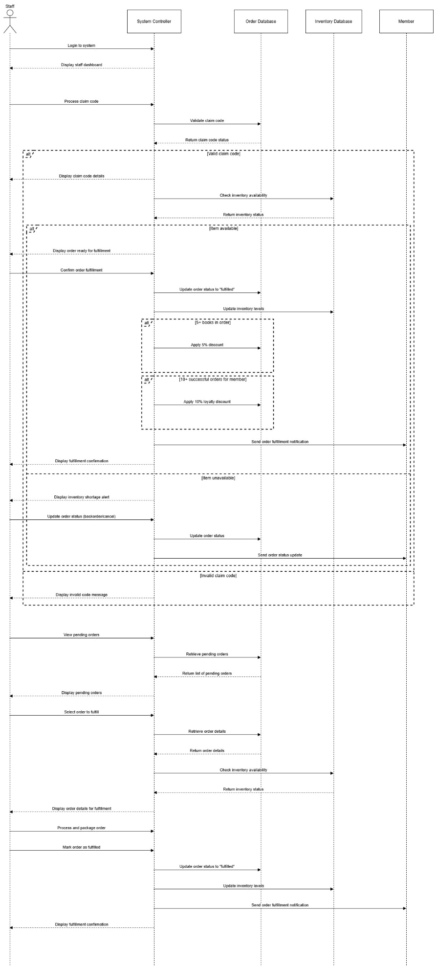

Figure 3: Sequence Diagram for Staff

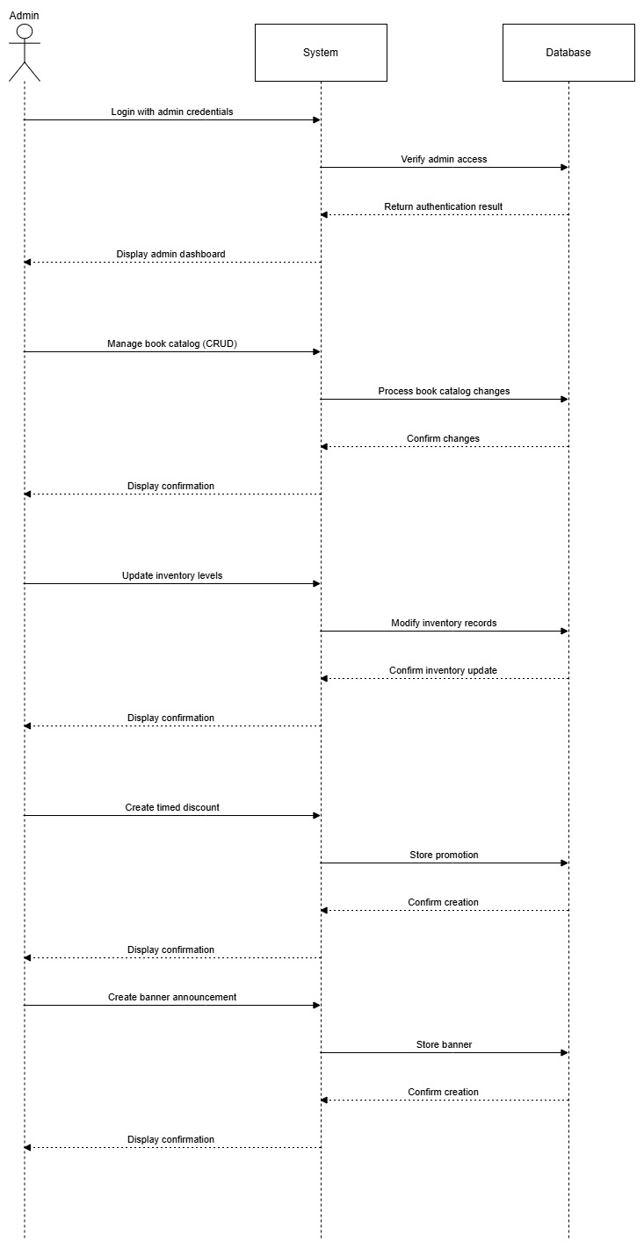

Figure 4: Sequence Diagram for Admin

## 3.3) VCS REPOSITORY:

## 3.4) MILESTONE CHART:

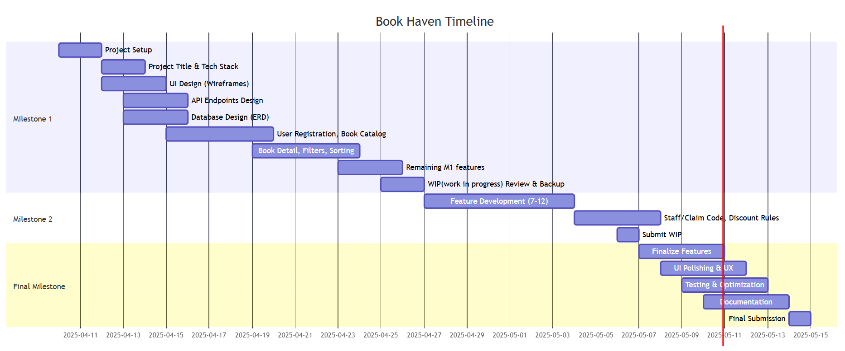

Figure 5: Milestone Chart Diagram

## 3.5) ERD DIAGRAM:

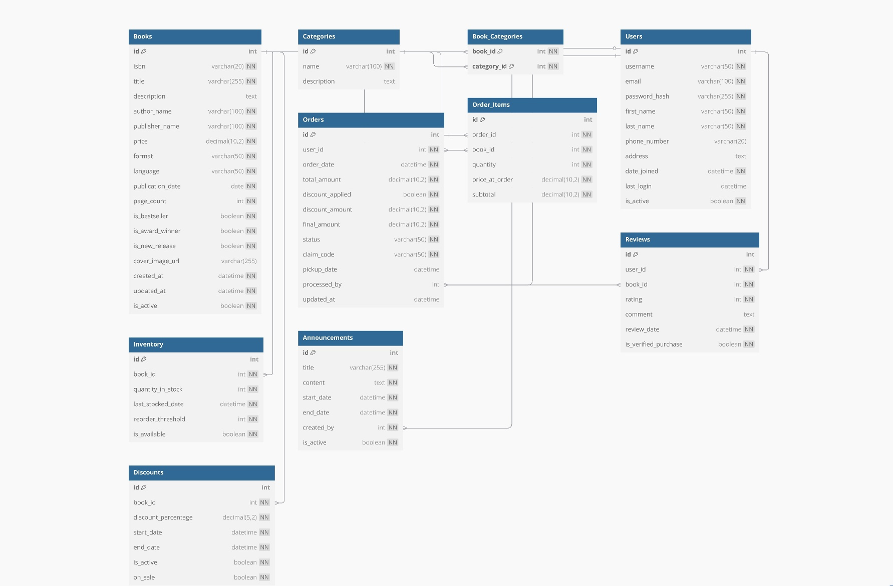

Figure 6: Entity Relationship Diagram

## 3.6) TESTINGS:

## 3.7 ) Tools & Technologies Used:

1. **.NET Web API:**

.NET Web API is a Microsoft framework designed for developing RESTful (Representational State Transfer) services that use HTTP. This framework enables applications to communicate over the Internet using standard HTTP methods (GET, POST, PUT, DELETE, etc.) (RESEARCH & DEVELOPMENT OF E-COMMERCE WEBSITE USING ASP. NET, 2023).

1. **PostgreSQL:**

PostgreSQL is a powerful and open-source object-relational database management system (ORDBMS), known for reliability, performance, and support for advanced features. PostgreSQL has a mature technology offering that enables full transactional support for both relational (SQL) and non-relational (JSON) queries. PostgreSQL is compliant with the ACID rulings established by the ANSI and ISO organizational recommendations, therefore ensuring data integrity, decentralized access, performance, triggers, stored procedures, full-text searching, and extensibility of custom data structures and functions (Google Cloud, 2024).

1. **Visual Studio:**

Visual Studio, by Microsoft is an all-in-one integrated development environment (IDE) that is primarily used for building computer programs for Windows, Web, Cloud, and mobile applications. Visual Studio can be used with many programming languages, for example, C#, C++, VB.NET, JavaScript, and Python. Visual Studio includes a code editor with IntelliSense code suggestions, debugging capabilities, connectivity to version control systems like Git, visual designers, and testing displays and options, deployment options, and more. Many features exist to bolster the productivity of developers: IntelliSense, refactoring code, and live code analysis (Microsoft, 2019).

**4) Swagger:**

Swagger is a collection of open-source tools that facilitate the design, development, documentation and consumption of RESTful web services. It creates a standard definition of an API using OpenAPI Specification (OAS). Swagger also allows developers to generate interactive documentation automatically. That means users can test endpoints directly from the documentation in their browser. Swagger allows you to generate code for clients and server stubs across a variety of languages. Swagger can enable better collaboration between the backend and frontend teams while helping improve the overall speed and ease of API development and maintenance by making API behaviour clear, and testable (SearchAppArchitecture, n.d.).

# 4. INDIVIDUAL REFLECTION:

## ROLES & RESPONSIBILITIES:

**1) Miraj Deep Bhandari:**

**Roles:**

I have done the uml diagrams including the use case sequence and also tracked the entire development process in milestone chart. I also worked in the database design, normalization and development of the erd. I have involved in the development of the front pages and its integrations and added the filter functionaly. For the backend I have involved in development for the api of the order process check, claim code process, review order, implemented the crud section for admin, involved in filters parts.

**personal insights:**

In completing this project, I learned a great deal about the entire full-stack development process. I saw how the multiple components of a system fit together from planning with UML to the implementation of front-end and back-end functions. Cooperation and communication with the group were crucial to align our requirements to get to a common goal.

**challenges:**

One of the biggest issues I confronted was getting the front-end and back-end interact smoothly, especially in having a constant flow of data and handling API responses. A second challenge was ensuring normalized schema structures and still having performance under control. Debugging filters and having proper data rendering in different roles took additional effort as well.

**learnings:**

I had the chance to experience system analyisis and design in the real world principally by creating UML diagrams and tracking milestones. I significantly advanced my understanding of concepts such as database normalization and ERD design. From a technical perspective I improved at API development, insuring front end integration, and completing CRUD operations efficiently. In addition, I learned how to handle my time through a development cycle and confidently adapt quickly when problems materialized.

**personal evaluation:**

All in all, I think I made a meaningful contribution to the project. I was involved in both facets, planning, and implementation, and got my work done on time. Although there were parts of the project I had to learn on the fly, I adapted and dealt with the issues. I feel more confident in my technical abilities, and my project management skills and am driven to develop them more in projects to come.

**2) Ayub Bhatta:**

# 5. CONCLUSION:

## 5.1 OBJECTIVE RESTATEMENT:

The main goal of this project was to convert an existing physical library store into a highly functioning online Book Store, using the C#.NET technology environment. The project set out to provide an online e-commerce style solution that is available to the public 24/7 while overcoming the limitations of a physical operation that ends up offering limited geographic support and regulation by time but still maintaining a service similar to that of a physical store.

## 5.2 IMPLICATIONS:

The successful development of this system marks a pivotal moment in digital transformation for small independently owned book sellers. It illustrates that, even with limited financial capital, organizations can use modern technology to expand their market, increase operational efficacy and enhance customer engagement through personalization and efficient services.

## 5.3 KEY FINDINGS:

* The ability to utilize advanced catalog filtering, membership capabilities, and loyalty structures can significantly enhance user retention and ease of shopping.
* The administrative tools of the GUI-based catalog manager, discount engine, and announcement module create significant efficiencies for operators.
* Community engagement features such as ratings and reviews improve usability and marketability.
* Omnichannel strategies such as in-store purchase collection using claim codes leverage digital conveniences with personalized service.

## 5.4 LIMITATIONS:

* The present system also does not include a direct online payment and shipping process, which may restrict access for remote customers.
* The lack of integration with large-scale analytics or recommendation engines limits automated personalization at scale.

## 5.5 RECOMMENDATIONS:

* In future development, the integration of secure payment gateways and delivery service integration should be front of mind.
* AI-based book recommendation engines and analytics dashboards would add to customer experience and business insights.
* The addition of mobile app development or responsive web design would expand usability across devices.

### 5.6 FUTURE RESEARCH & DEVELOPMENT:

* Exploration into partnerships with digital publishing platforms or audiobook platforms could yield new revenue sources.
* The creation of an AI-powered chatbot to provide customer service and guided navigation for users could enable immediate user assistance.
* Research into blockchain for user loyalty program transparency or secure transactional services could provide new insights.

## 5.7 CONCLUDING STATEMENT:

In conclusion, this project marks a monumental step in taking a traditional library store into cyberspace by developing a feature packed, scalable, easy-to-use online book retail system in C#.NET. The application has met the organizations need and goals, such as overcoming challenges faced in the business due to distance, hours of operation, and product availability, while maintaining the personalized experience that identifies the store. User features of advanced catalog filtering, secure membership management, in-store pickup ordering, loyalty rewards and community reviews provide customers with an exciting user and customer experience. On the administrative side, catalog management, inventory control, and promotion management tools can automate the cumbersome processes of managing their catalog and fulfilling orders, which helps reduce the work load of staff while meeting customer needs. This project has provided many learning opportunities in full-stack development, database design, and system integration, and developed the full-range of the team technically and professionally. While the current version does not cover an online payment or shipping service, it is designed with a scalable architecture, meaning that the next developers can add those features. This system creates a bridge between the traditional retail values and a new e-retail environment for the library store promoting social engagement to grow their overall customer reach. The organization and team is well positioned to continue to grow, connect with customers, and be a key player in the competitive book selling world through e-commerce.

# 6. REFERENCES:

* Google Cloud. (2024). *What Is PostgreSQL? Databases Explained*. [online] Available at: https://cloud.google.com/discover/what-is-postgresql.
* Microsoft (2019). *Visual Studio*. [online] Visual Studio. Available at: https://visualstudio.microsoft.com/.
* RESEARCH & DEVELOPMENT OF E-COMMERCE WEBSITE USING ASP. NET. (2023). *International Journal of Progressive Research in Engineering Management and Science*. doi:https://doi.org/10.58257/ijprems30933.
* SearchAppArchitecture. (n.d.). *What is Swagger? Definition from WhatIs.com*. [online] Available at: https://www.techtarget.com/searchapparchitecture/definition/Swagger.